Appendix 4 - ImageJ

ImageJ is a free, user-friendly application for analyzing color, size, and other attributes within image files. The application can be downloaded at http://rsbweb.nih.gov/ij/index.html.

To quantify the land cover indicated in a landscape shown within the MRLC Consortium Viewer, make a screen grab of the landscape visualization (using Windows Snipping Tool, or the Mac OS see http://www.wikihow.com/Take-a-Screenshot-in-Mac-OS-X ) to copy the section of the land use image you intend to analyze. In ImageJ, select the scroll-down menu File > New > Image. Name the file if you intend to save it, modify the Type if you wish, then paste the screen grab into the panel.

Click the Square Icon to select area to analyze. After selecting the area of the image that indicates land use, select the scroll-down menu Analyze > Histogram. This will provide a figure showing a pixel count of each color class. In the Histogram panel, click List. This will provide a text list of each color class, and the count of pixels at that pixel class. Select the scroll-down menu File > Save as.. Save this file, which can be opened in Excel (or other spreadsheet program) to calculate the proportional coverage of each land use class (see Appendix 5).

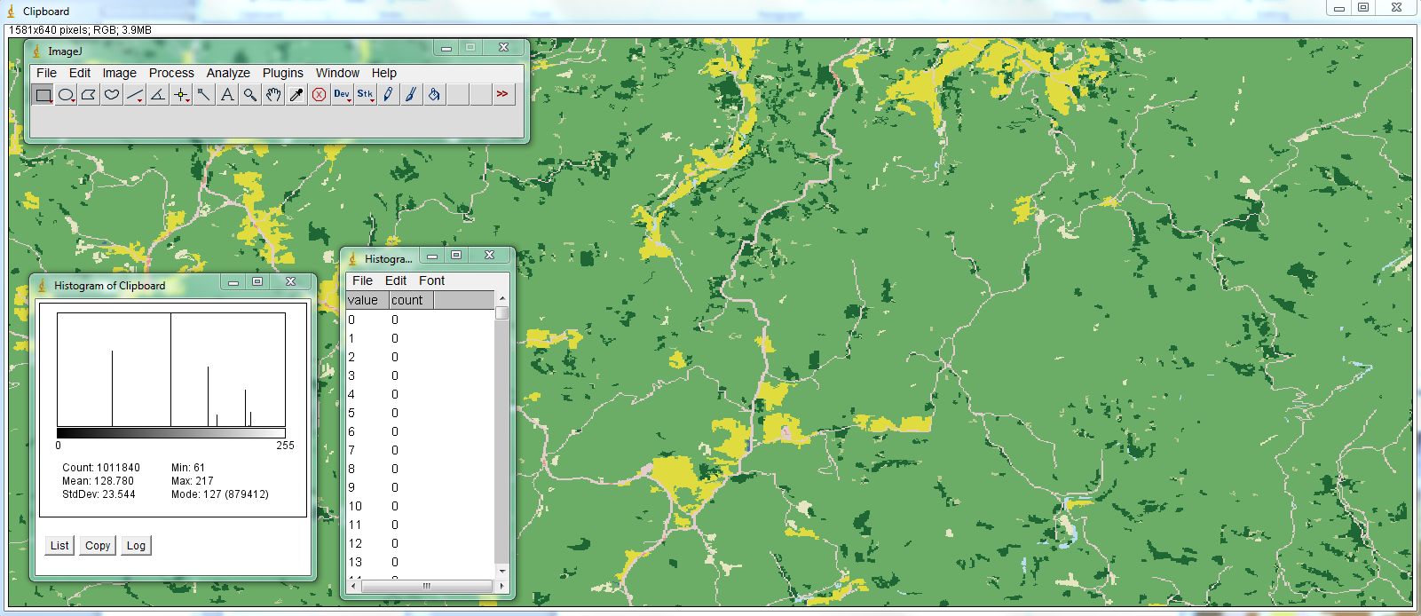
List of histogram data
To list histogram data
Analysis scroll-down, contains option histogram
Image
view
Button to select image section for analysis
Color
histogram

